**Modeling phase**

**Gradient Boosting Regressor Model:**

The main idea behind this algorithm is to build models sequentially and these subsequent models try to reduce the errors of the previous model, The objective here is to minimize the loss function by adding weak learners using gradient descent algorithm, Decision trees are used as the weak learner in gradient boosting, Specifically, regression trees are used that output real values for splits and whose output can be added together, allowing subsequent models outputs to be added and “correct” the residuals in the predictions, Trees are constructed in a greedy manner, choosing the best split points based minimize the loss function.

**The results of the model on the dataset which preprocessed with one hot encoding technique:**

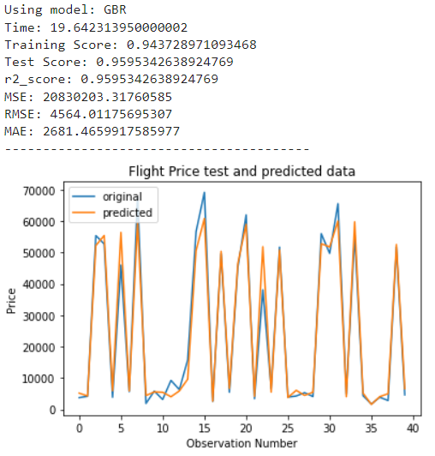

**The results of the model on the dataset which preprocessed with target encoding technique:**

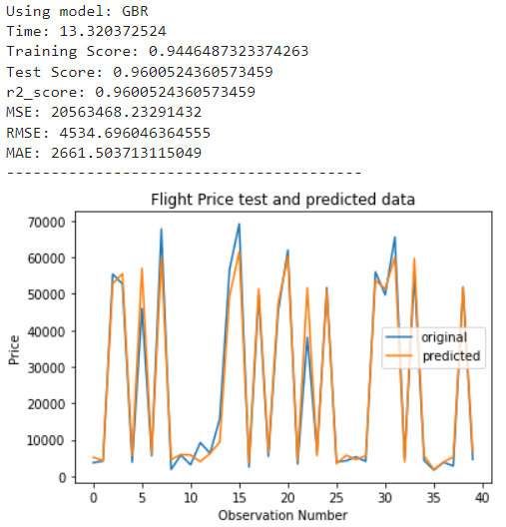

**The results of the model on the dataset which preprocessed with one Frequency domain encoding technique:**

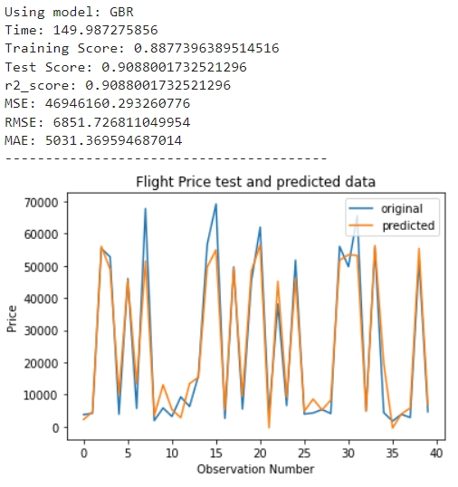

**Extra Trees Regressor Model:**

Extra Trees is an ensemble machine learning algorithm that combines the predictions from many decisions trees, The Extra Trees algorithm works by creating a large number of decision trees from the training dataset. Predictions are made by averaging the prediction of the decision trees

**The results of the model on the dataset which preprocessed with one hot encoding technique:**

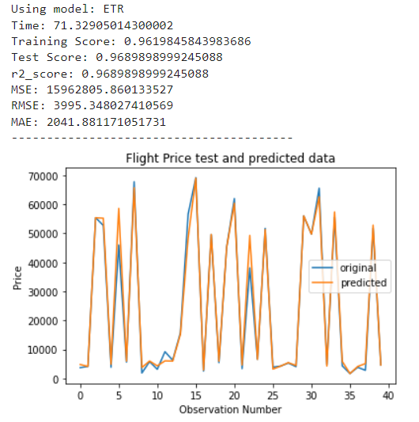

**The results of the model on the dataset which preprocessed with target encoding technique:**

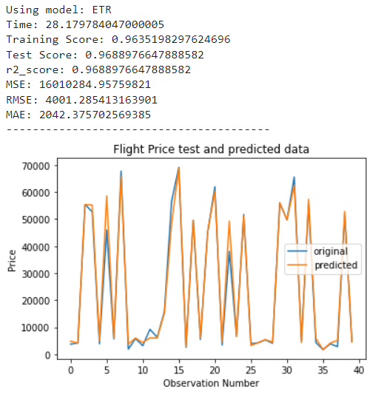

**The results of the model on the dataset which preprocessed with one Frequency domain encoding technique:**

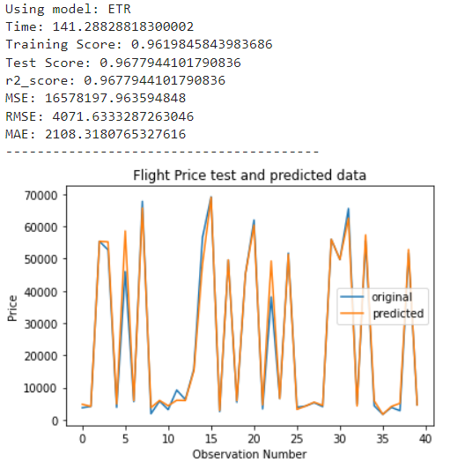

**Multiple Linear Regression Model:**

Multiple regression is a technique that can be used to analyze the relationship between a single dependent variable and several independent variables. The objective of multiple regression analysis is to use the independent variables whose values are known to predict the value of the single dependent value. Each predictor value is weighed, the weights denoting their relative contribution to the overall prediction.

**The results of the model on the dataset which preprocessed with one hot encoding technique:**

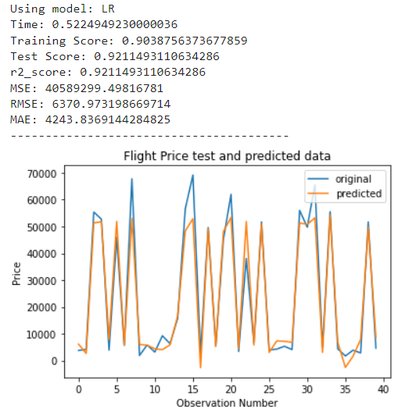

**The results of the model on the dataset which preprocessed with target encoding technique:**

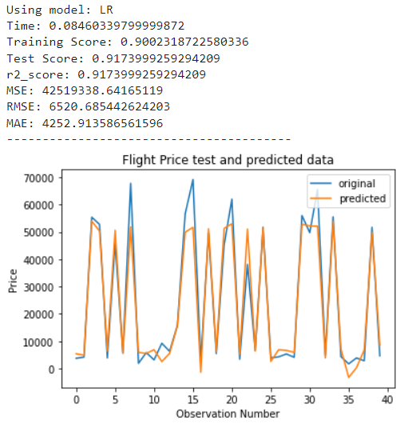

**The results of the model on the dataset which preprocessed with one Frequency domain encoding technique:**

